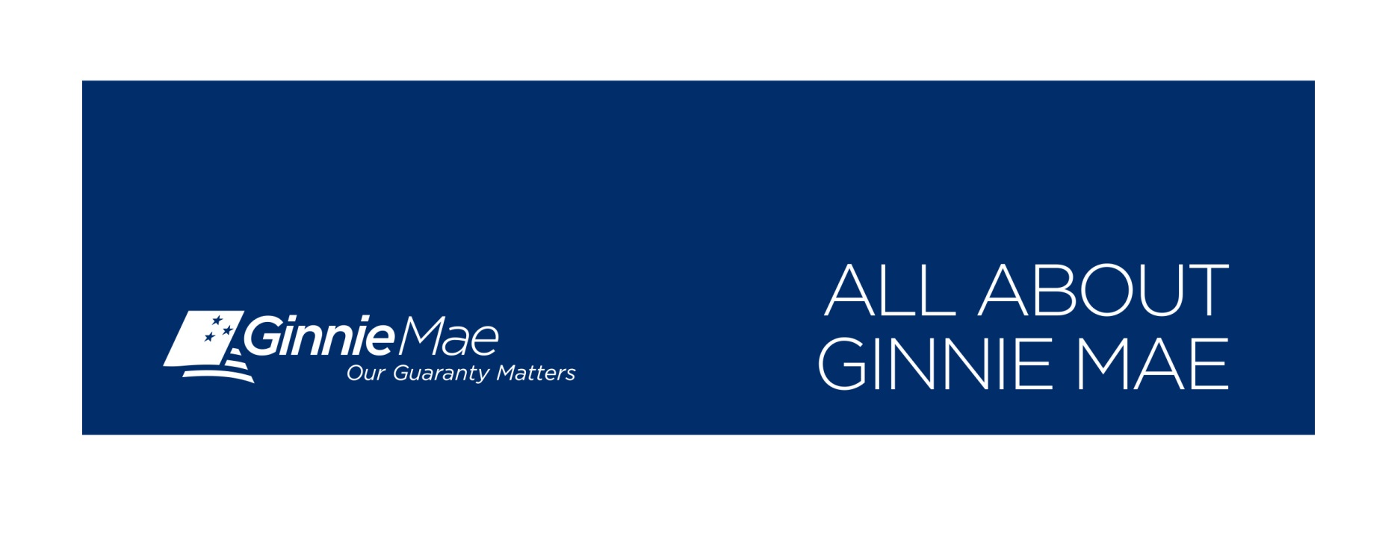

**Key Information**

**Address** Mailing Physical

550 12th Street, NW 451 7th Street, SW, Room B-133

Washington, DC 20024 Washington, DC 20410

**Phone** 888-446-6434

**Website** www.ginniemae.gov

**Key** **Executives** *Honorable Theodore Tozer*, President

**Founded** 1968

**Employees** 127

**Taxpayer Savings** Returned $2.2 billion to the United States Treasury

**Market Share** 39 percent share of secondary mortgage market, virtually all of government market

**FY2015 Issuance** More than $432 billion in new MBS, surpassing Freddie Mac for entire fiscal year and Fannie Mae in latter half of FY2015.

**Pass Through** Pass-through to investors for FY2015 was $104,581,673,623 for Ginnie Mae I; $301,280,798,994 for Ginnie Mae II.

**Mission**

[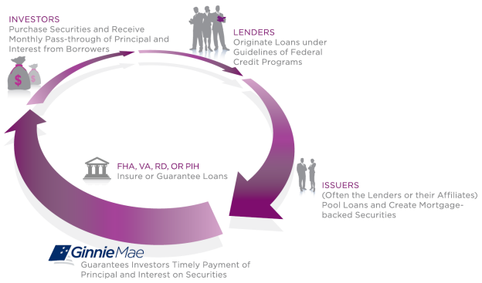](http://ginniemae.gov/inside_gnma/company_overview/PublishingImages/countercyclicalrole.png)Ginnie Mae helps veterans and low and middle income families purchase homes by ensuring they can get an affordable mortgage. We are like the Federal Deposit Insurance Corporation, only for the government mortgage market.

Ginnie Mae is a self-sustaining, profitable, wholly-owned government corporation located within the U.S. Department of Housing and Urban Development. Ginnie Mae brings global capital into the housing finance market — a system that runs through the heart of our nation's economy — while minimizing risk to the taxpayer.

For more than 40 years, Ginnie Mae has provided liquidity and stability, serving as the principal financing arm for government loans and ensuring that mortgage lenders have the necessary funds to provide loans to consumers. Ginnie Mae delivers mortgage securitization programs for mortgage lenders and attractive offerings for global investors.

**Ginnie Mae History**

Ginnie Mae’s origins trace back to the Great Depression, when historically high unemployment rates led to an unprecedented wave of loan defaults. In 1934 Congress passed the National Housing Act, which created the Federal Housing Administration (FHA), to help resuscitate the U.S. housing market and protect lenders from mortgage default. The Act was amended in 1938 to charter the Federal National Mortgage Association (FNMA), or Fannie Mae, whose purpose was to create a secondary mortgage market by purchasing FHA-insured loans from lenders and thus provide liquidity to support the flow of credit. The Housing and Urban Development Act of 1968 subsequently split Fannie Mae into two separate corporations: Fannie Mae, to purchase conventional (non-U.S. government-insured or government-guaranteed) mortgages that conformed to specific underwriting standards, and the Government National Mortgage Association (GNMA), or Ginnie Mae, to focus on providing a guaranty backed by the full faith and credit of the United States for the timely payment of principal and interest on mortgage-backed securities (MBS) secured by pools of government home loans.  In 1970 Ginnie Mae developed the very first mortgage-backed security (MBS), which allowed for many loans to be pooled and used as collateral in a security that could be sold in the secondary market, to provide a greater flow of capital.

**Model**

Ginnie Mae's business model significantly limits the taxpayers' exposure to risk associated with secondary market transactions. Its strategy is to guarantee a simple pass-through security to lenders rather than buy loans and issue its own securities.

[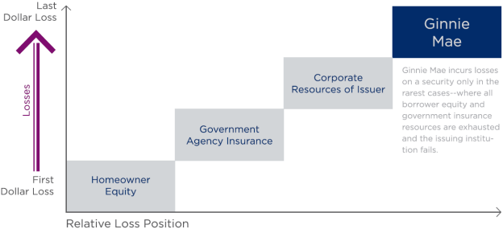](http://ginniemae.gov/inside_gnma/company_overview/PublishingImages/businessmodel3.png)Because private lending institutions originate eligible loans, pool them into securities and issue Ginnie Mae mortgage-backed securities (MBS), the corporation's exposure to risk is limited to the ability and capacity of its MBS Issuer partners to fulfill their obligations to pay investors. By guaranteeing the servicing performance of the Issuer — not the underlying collateral — Ginnie Mae insulates itself from the credit risk of the mortgage loans.

Ginnie Mae is in the fourth loss position and is at risk once the three preceding layers of risk protection are exhausted or fail. Additionally, the failure of an Issuer will cause Ginnie Mae to experience financial loss only to the extent that funds are needed to transfer the servicing to another Issuer or to the extent there is deterioration in servicing value.

Ginnie Mae monitors the delinquencies in Issuer servicing portfolios in an efficient and effective manner to mitigate the potential losses associated with Issuer defaults.

**Ginnie Mae and the GSEs**

The key differences between Ginnie Mae and the Government-Sponsored Enterprises (GSEs), include:

* Only Ginnie Mae securities are explicitly backed by the full faith and credit of the U.S. Government.
* Ginnie Mae is a self-sustaining, profitable and wholly-owned government corporation located within the U.S. Department of Housing and Urban Development (HUD), while the GSEs are public corporations chartered by Congress, but owned by shareholders*.
* Ginnie Mae’s business model significantly mitigates taxpayers’ exposure to risk associated with mortgage securitization.
* In the Ginnie Mae program, Issuers are financially responsible for their securities, even if the underlying mortgage collateral becomes delinquent.
* Ginnie Mae has never needed a taxpayer-footed, government bailout.